Skill 1 – Encapsulation Builder
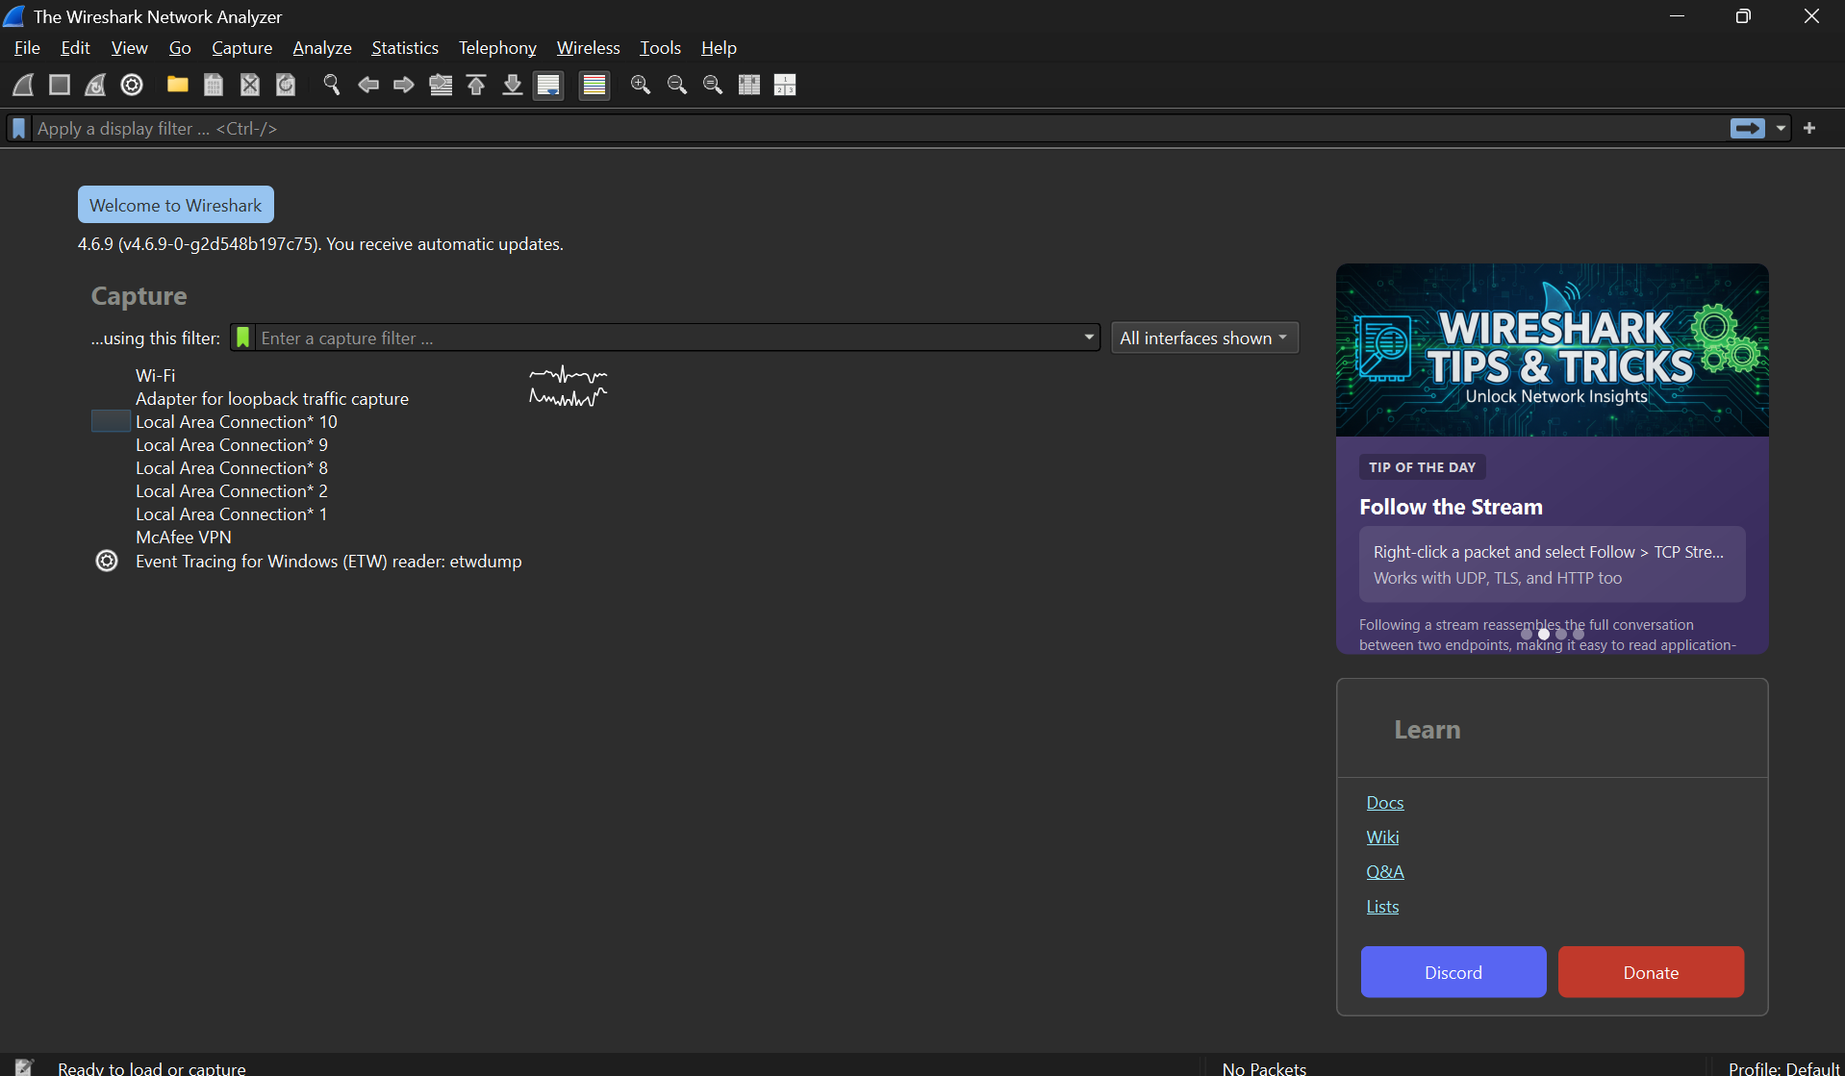

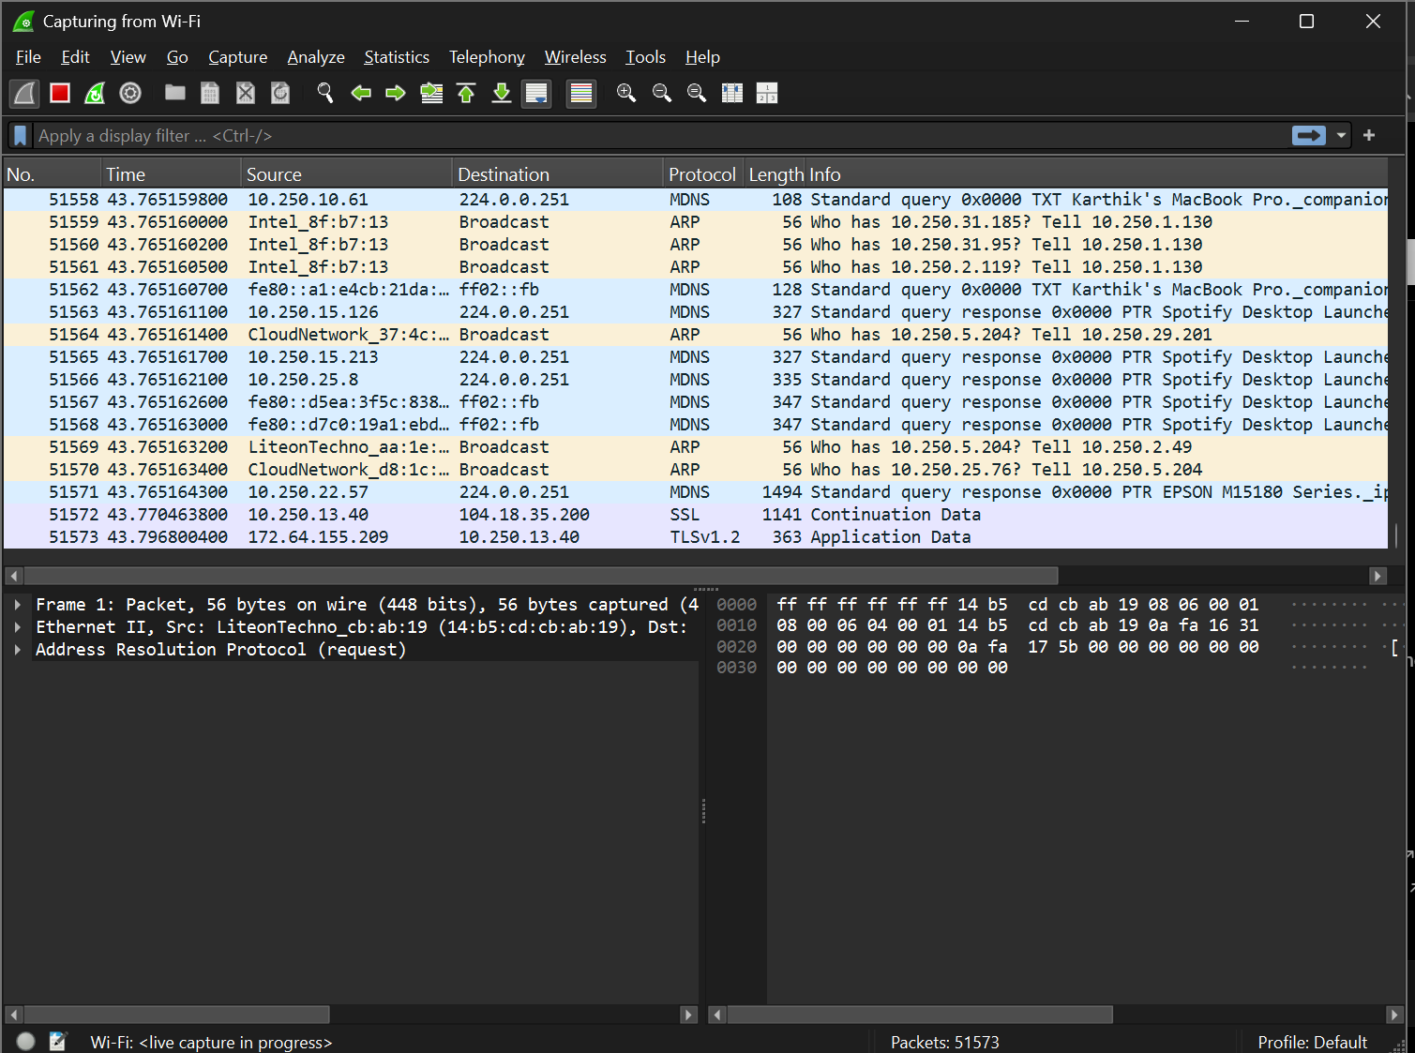
After stop
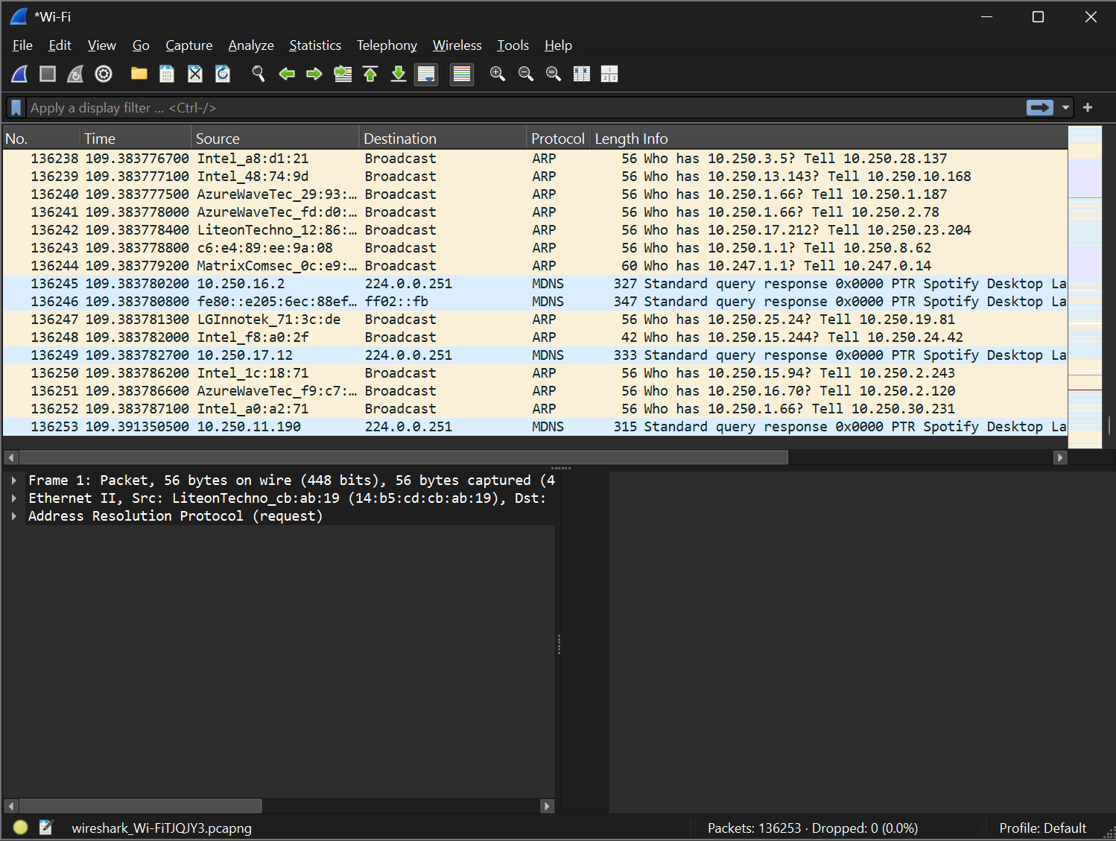
Step 4 – Apply TCP and UDP filters
Tcp filters
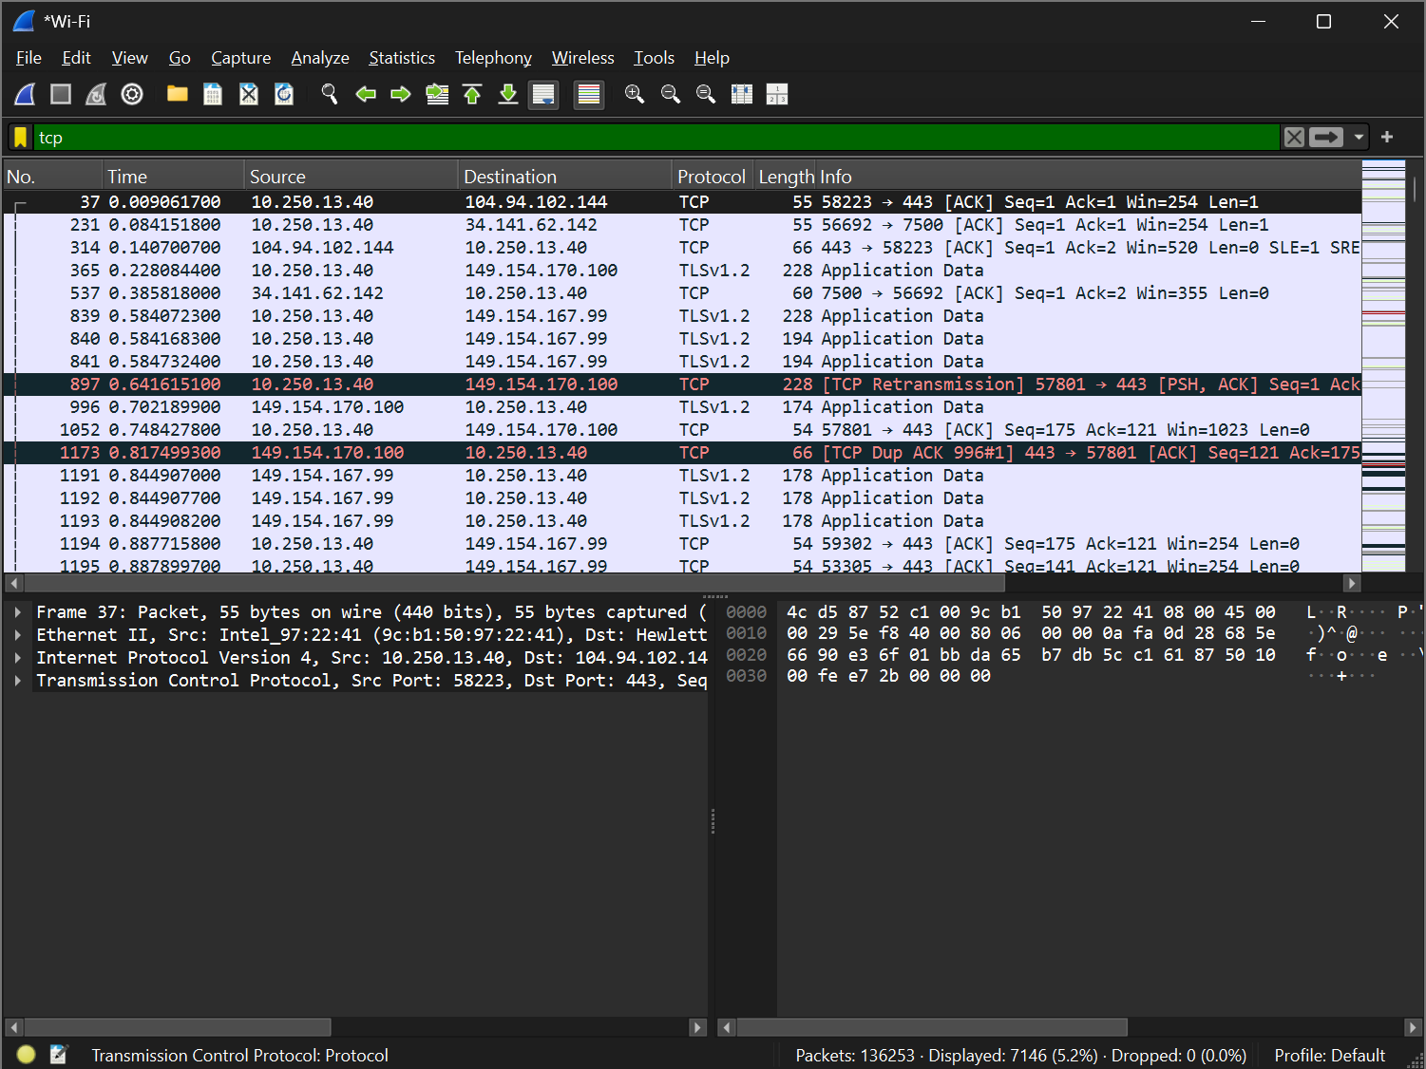
Udp

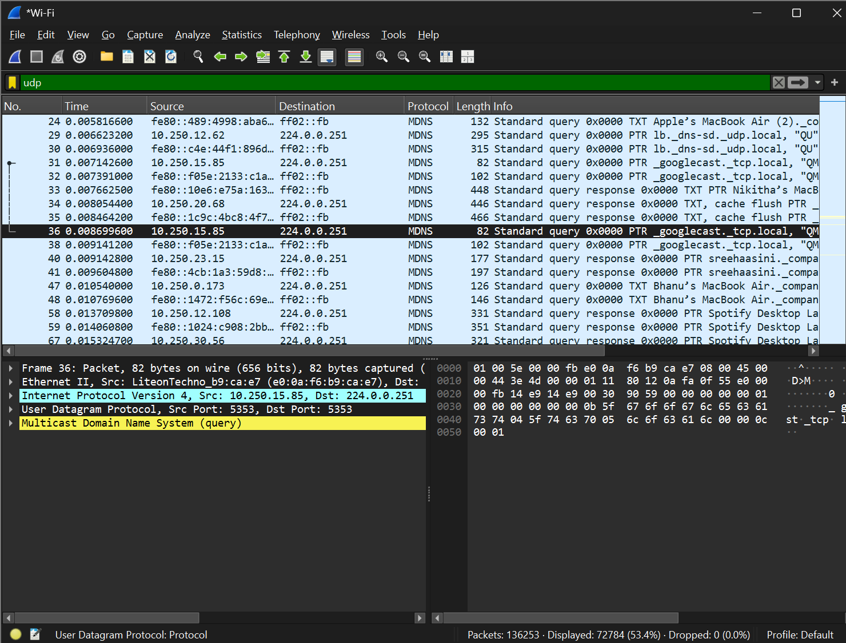
Step 5 – Analyze TCP Packet Headers
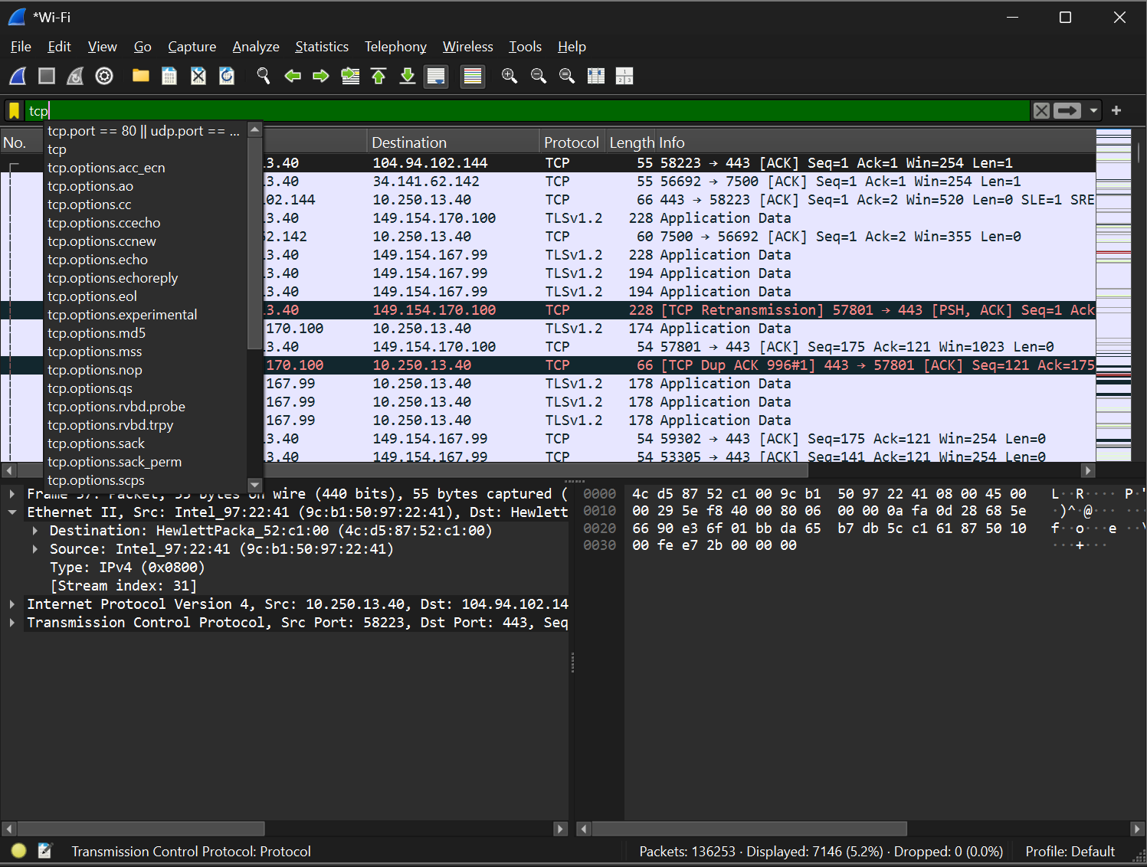
Part C: Expand IPv4
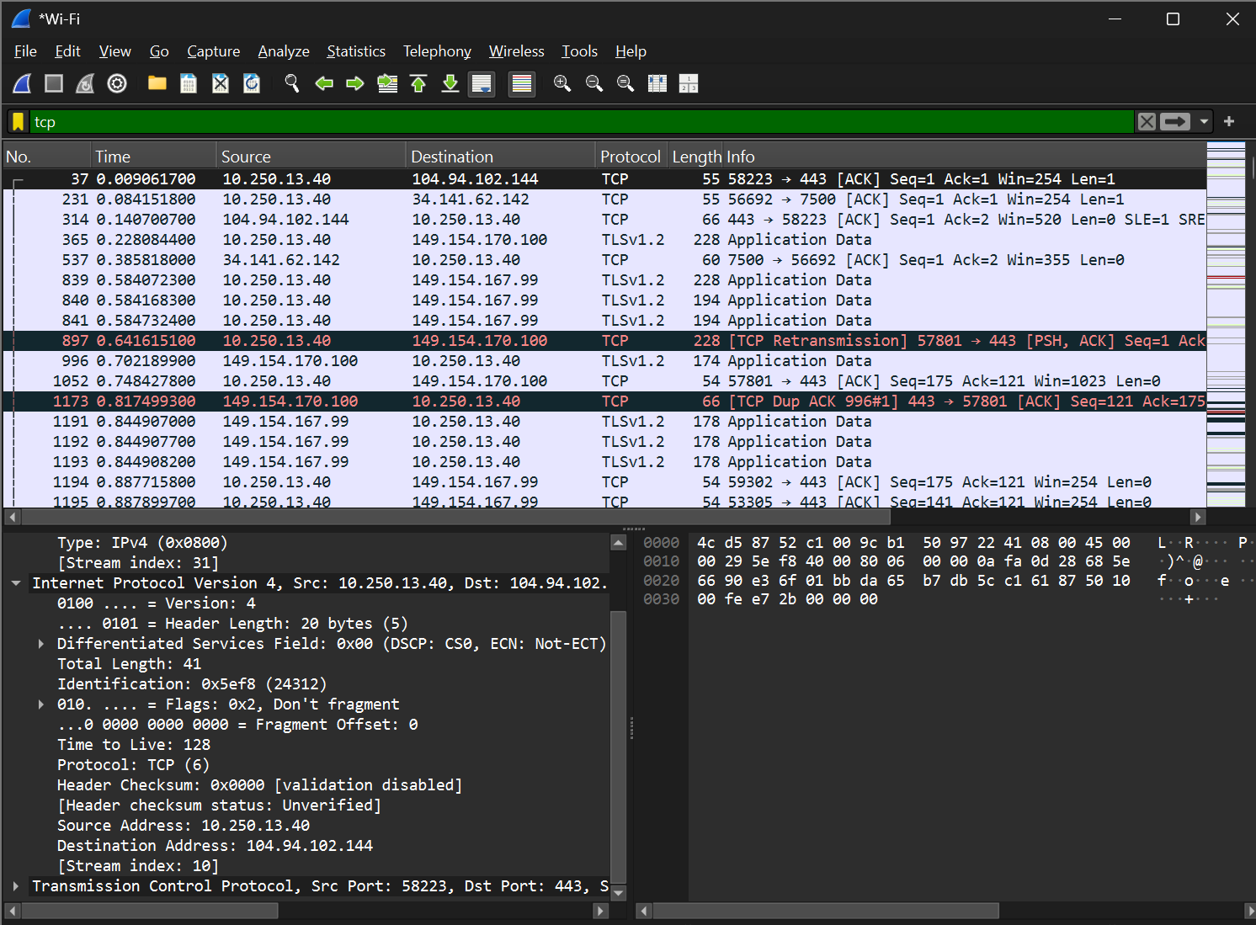
Step 5 – Part D: Expand TCP header
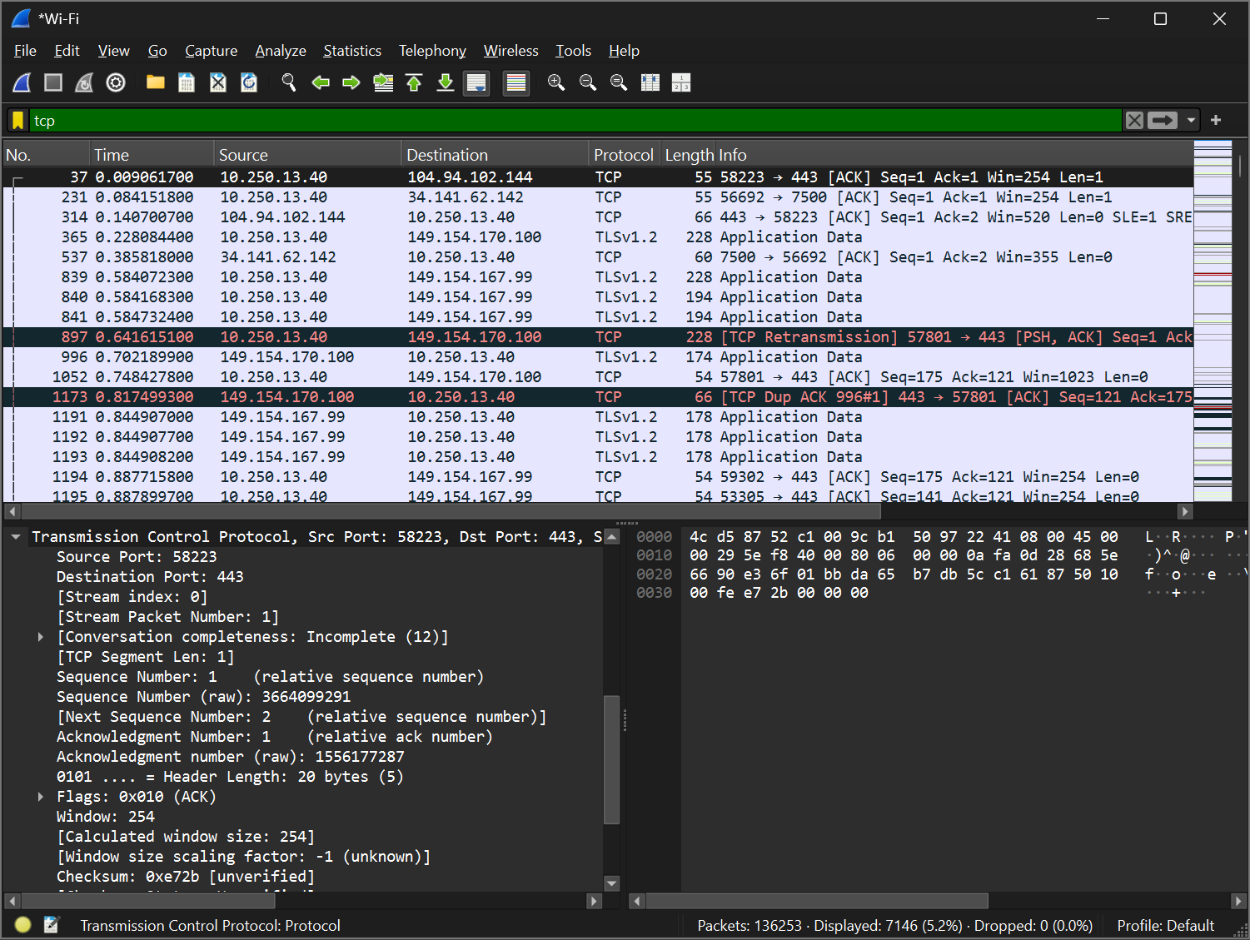
Step 6 – Analyze UDP packet headers
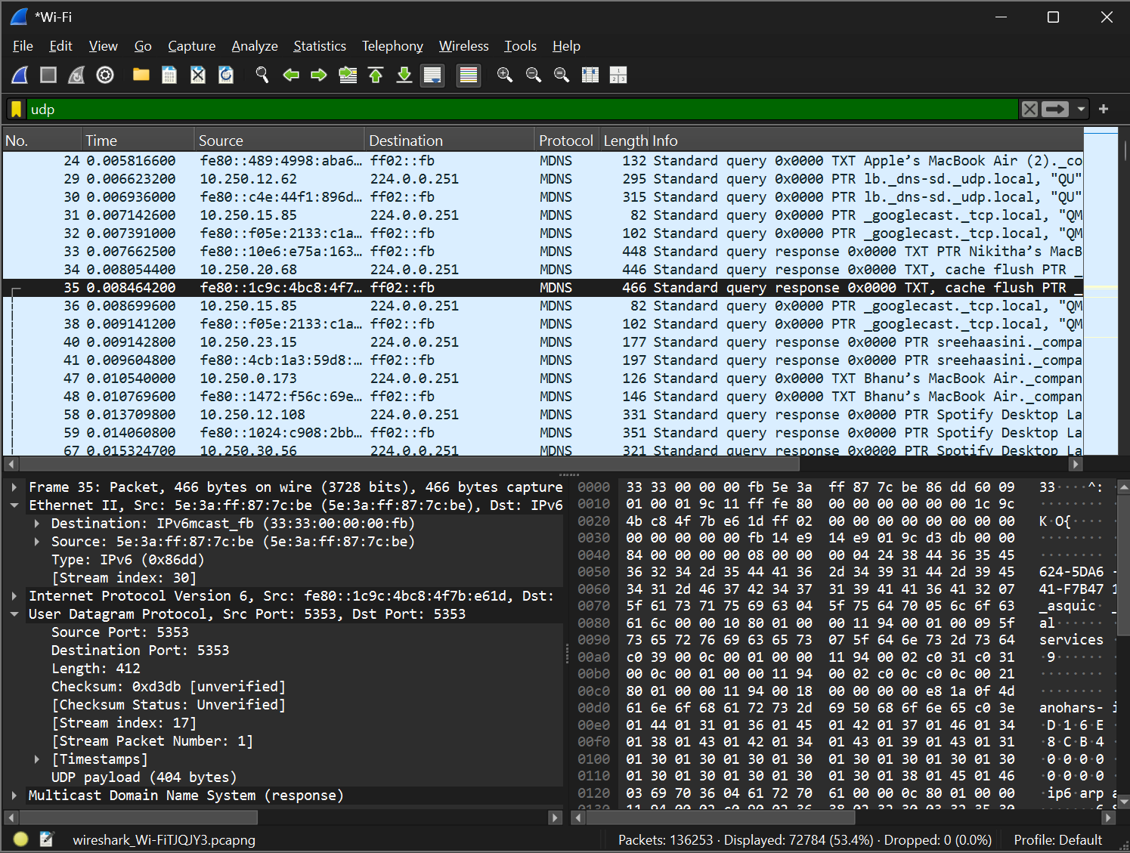
Step 7 – Apply TCP data filter
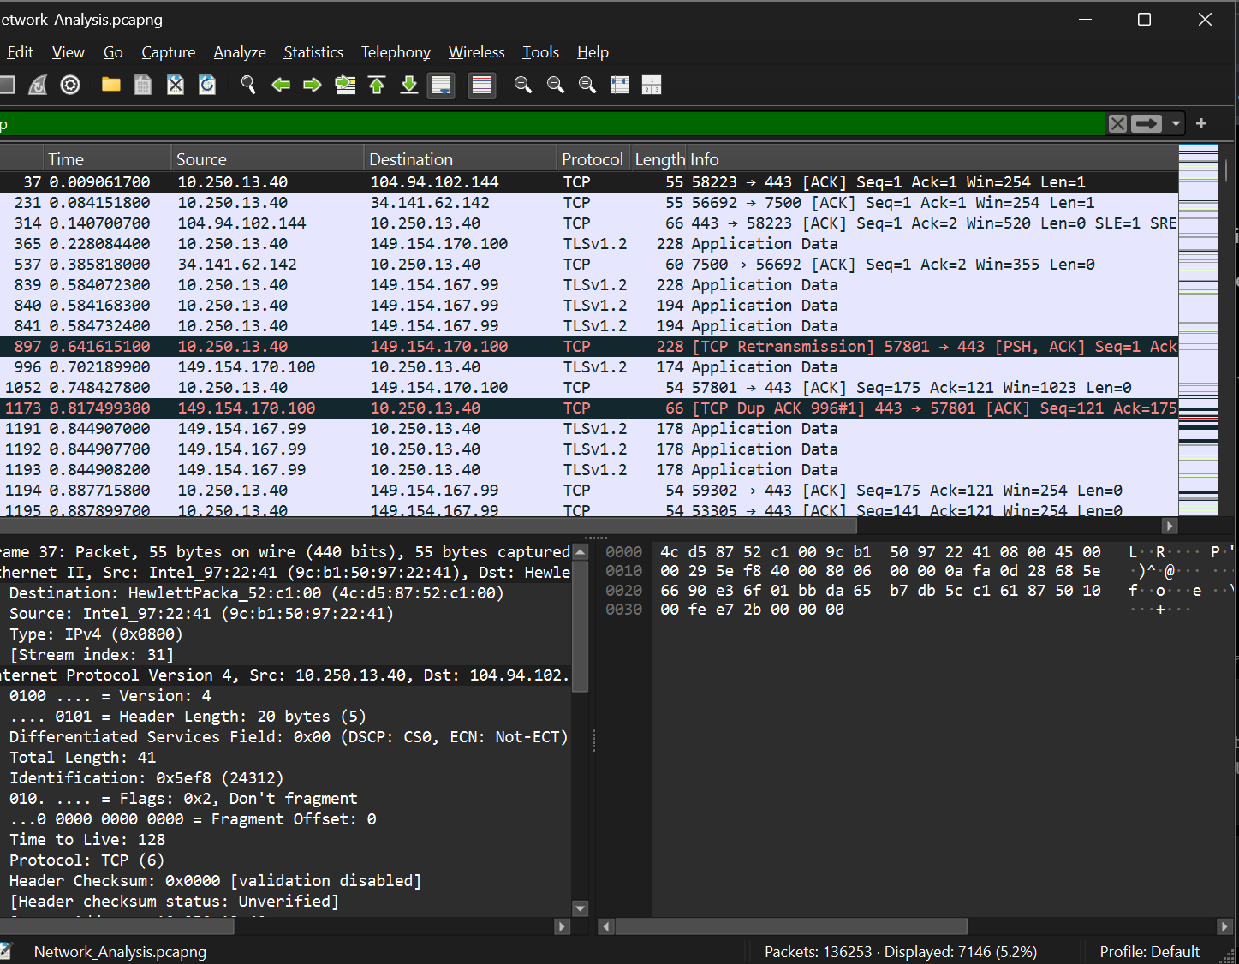

Conclusion: Successfully analyzed packet encapsulation using Wireshark. Observed Ethernet, IP, TCP, and UDP headers, identified header fields, and examined packet lengths and payloads.

